Assembly Language Report (HW1-Arithmetic)

資工2A

104502518劉冠聲

Program CODE:

.data

;my last 4 studentID is 2518

Digit0 BYTE 2h ;store 2 in variable Digit0

Digit1 BYTE 5h ;store 5 in variable Digit1

Digit2 BYTE 1h ;store 1 in variable Digit2

Digit3 BYTE 8h ;store 8 in variable Digit3

MyID WORD ? ;initialize variable MyID

.code

; main procedure

start@0 PROC

mov ah,Digit0 ;store 2 into ah, now register ax is 0x0200

shl ah,4 ;left shift ah, now register ax is 0x2000

add ah,Digit1 ;add 5 into ah, now register ax is 0x2500

mov al,Digit2 ;store 1 into al, now register ax is 0x2501

shl al,4 ;left shift al, now register ax is 0x2510

add al,Digit3 ;add 8 into al, now register ax is 0x2518

mov MyID,ax ;store 2518 into variable MyID, now MyID is 0x2518

exit

Picture & Discription:

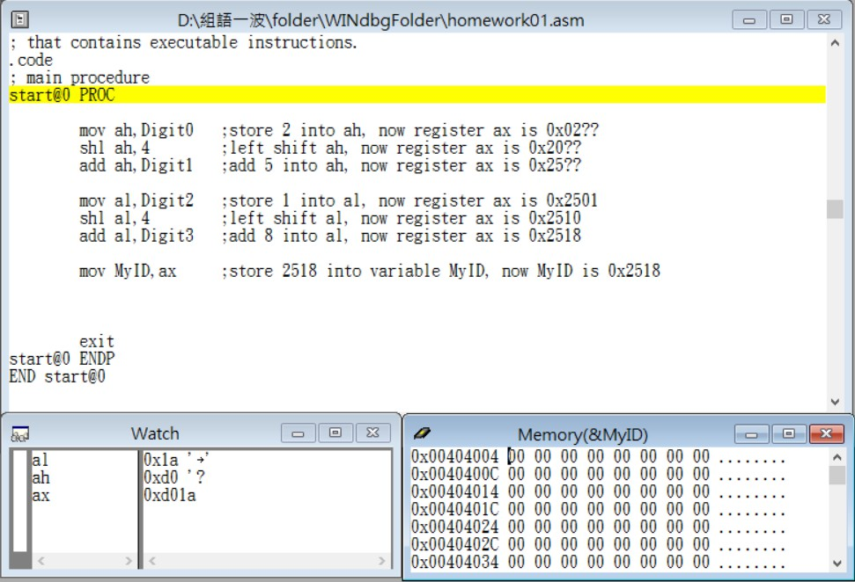

Step1: start

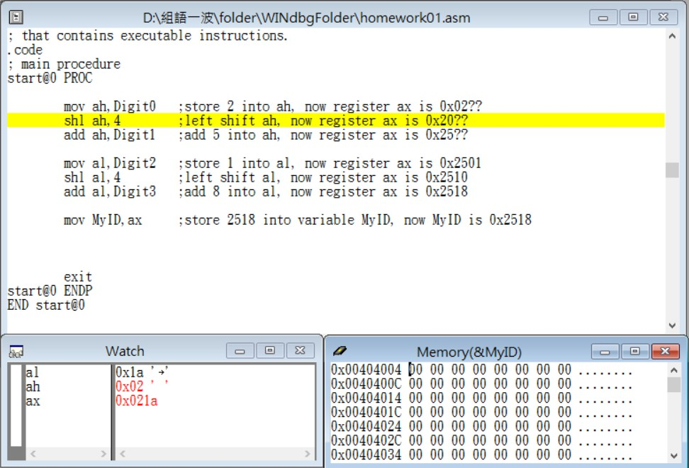

Step2: store Digit0(02h) into register ah

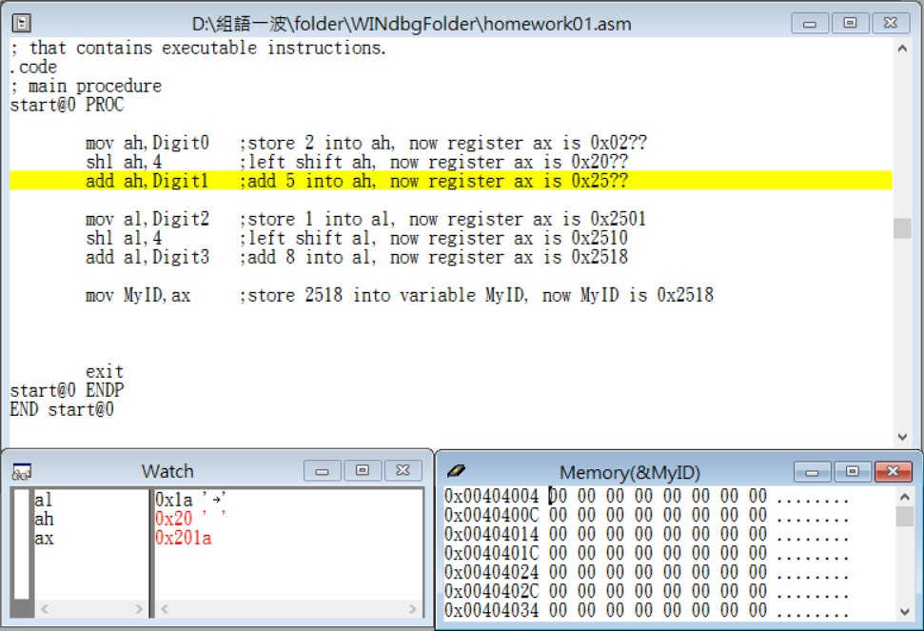

Step3: 4 left shift ah(02h→20h)

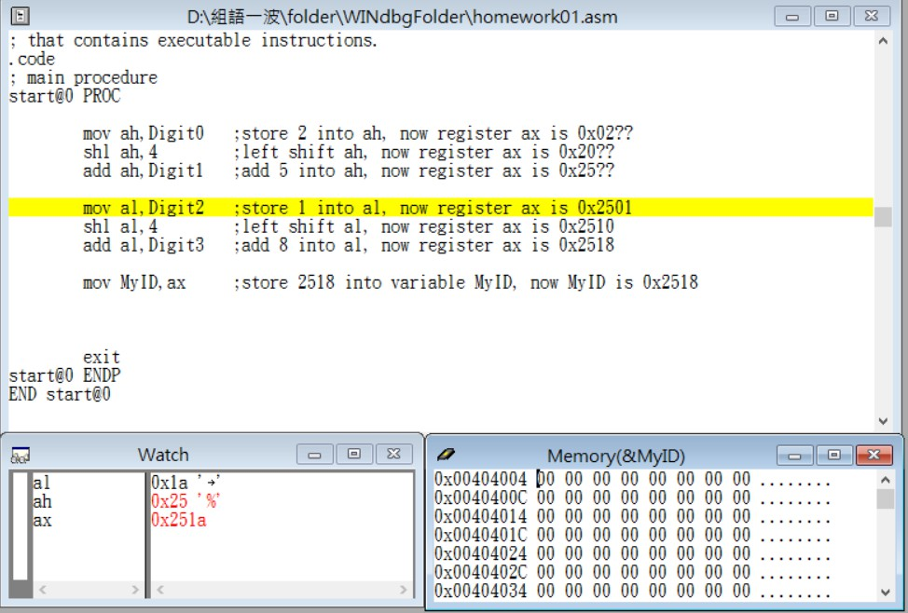

Step4: add Digit1(05h) into register ah(20h→25h)

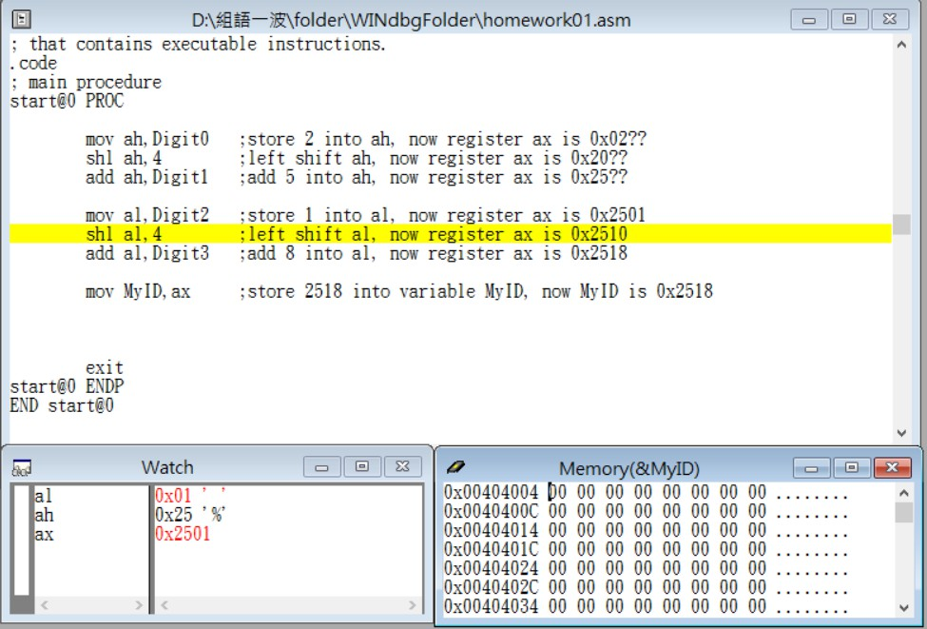

Step5: store Digit2(01h) into register al

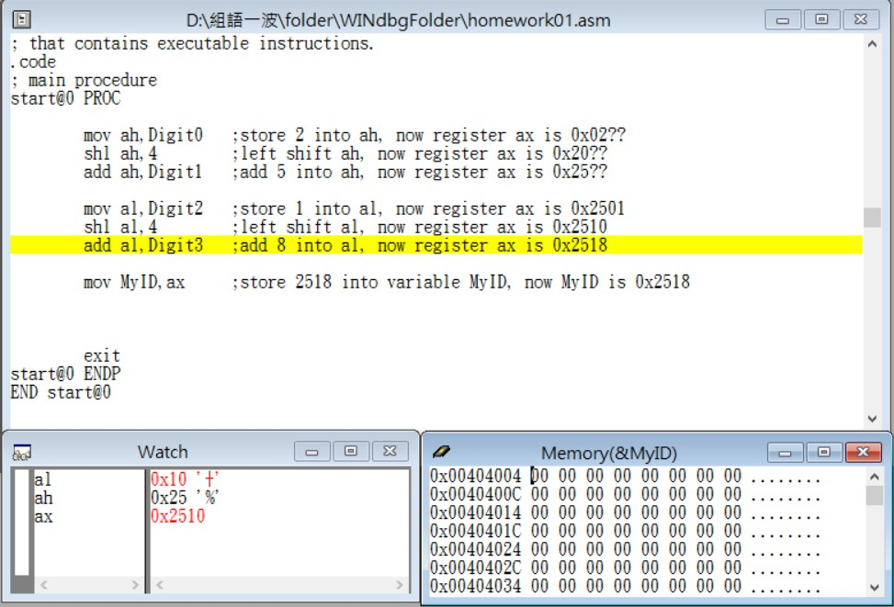

Step6: 4 left shift al(01h→10h)

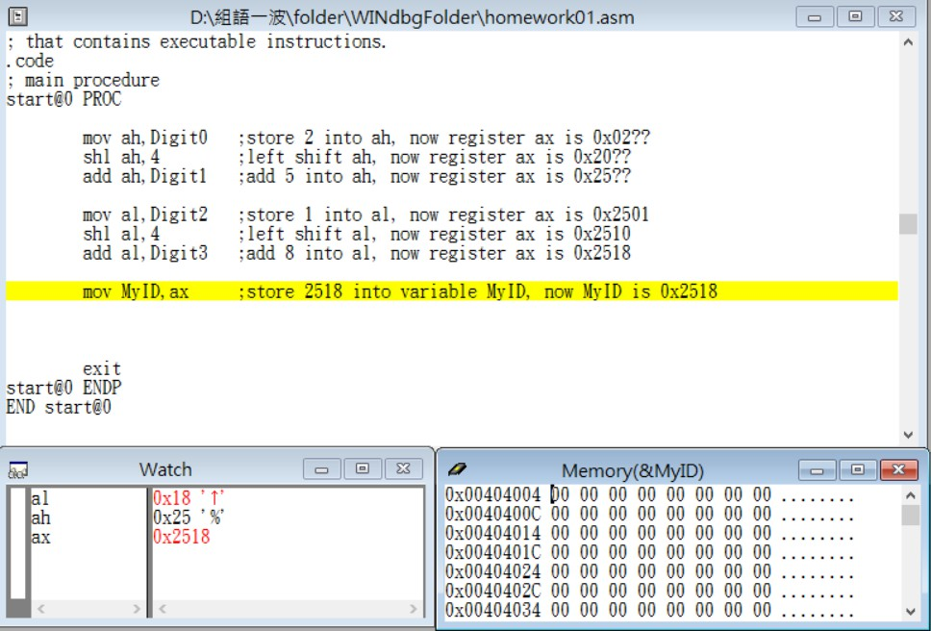

Step7: add Digit3(08h) into register al(10h→18h)

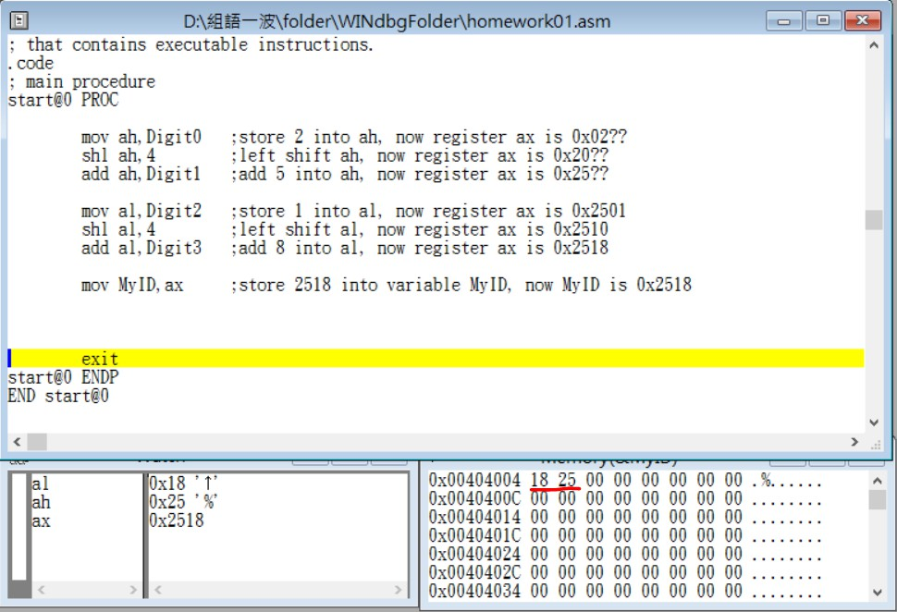

Step8: store ax(my student ID : 2518) into MyID

(the end)

Review:

In the beginning, I calculated byte and hexadecimal for a long time, finally remembered that 1 byte = 2 hexidecimal number.

And then I met the second problem, how should I place my last 4 student ID into register respectively, thinking for a while, my memory in class came up, use shift to combine them. So I quickly completed all my code and think that it is pretty easy, but I got a bug then. I couldn’t understand why, where is the bug. My file make.bat didn’t produce the .exe file.

Eventually I found that I typed the command “move” not “mov” …… well …… I’m stupid.